Comprehensive Report: Demographic Classification & Key Segments Analysis

**Introduction:**

Understanding customer demographics and identifying key segments is essential for developing targeted credit card offerings that cater to specific customer needs and preferences. This report presents the findings and insights derived from analyzing customer demographic data provided by Mitron Bank.

It answers the following questions;

1. What is the age distribution of the customers?
2. What is the highest spending age group?
3. Married vs Single, who spends more?
4. What are the spending distributions of Married vs Single people?
5. What is the highest spending occupation?
6. What are the spending distributions of the various occupations?
7. What is the highest spending gender?
8. What are the spending distributions of Males vs Females?
9. What is the relationship between Spending and Average Income?

**Data Overview:**

The dataset contains demographic information for 4000 customers, including age group, city, occupation, gender, marital status, and average income. The data was gotten from Kaggle and the research is based on this dataset.

**Data Cleaning:**

The data originally came with 864,000 rows and 5 columns. It was found that a big portion of data was duplicated. The duplicates were removed, and as a result it was cut down to just 4000 rows and 5 columns. No missing values were recorded.

**Data Analysis:**

**Age Group Distribution**

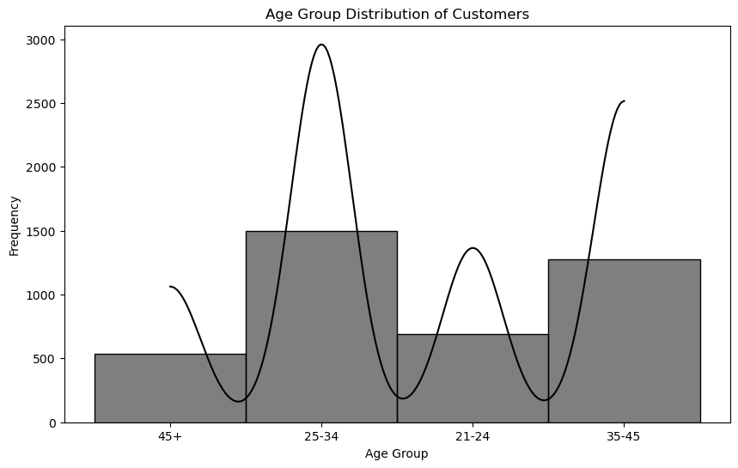

Ages 25-34 make up the majority of the customer base.

**Spending by Age Group**

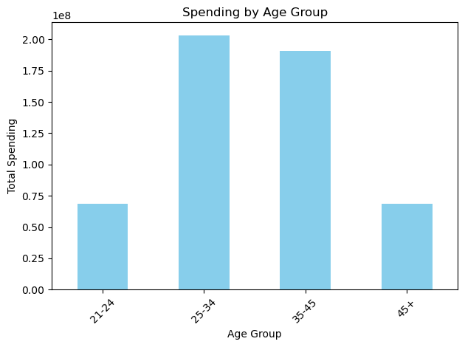

It was found that the age group with the highest spending was the ages 25-34. This was followed by ages 35-45.

**Spending by Marital Status**

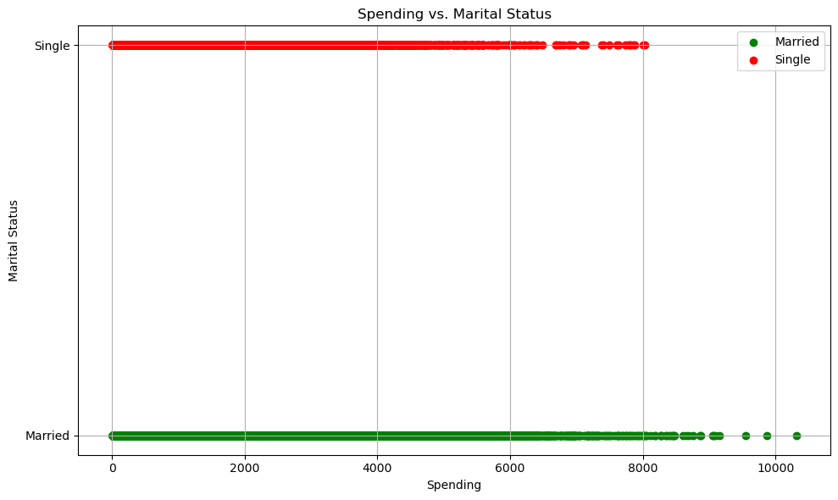

It was found that married people on average spend more than the single people.

**Spending Distribution by Marital Status**

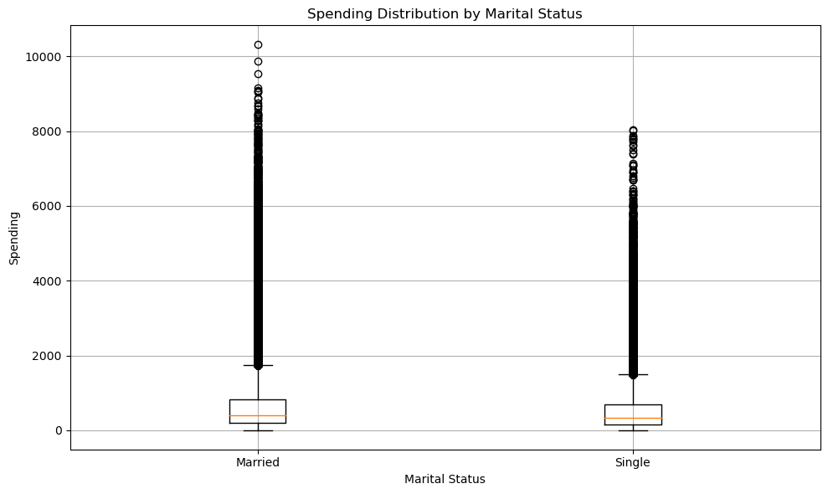

Although the Single people spent less, we can see here that they have around the same average amount spent with the Married people. Both have multiple positive outliers.

**Spending by Occupation**

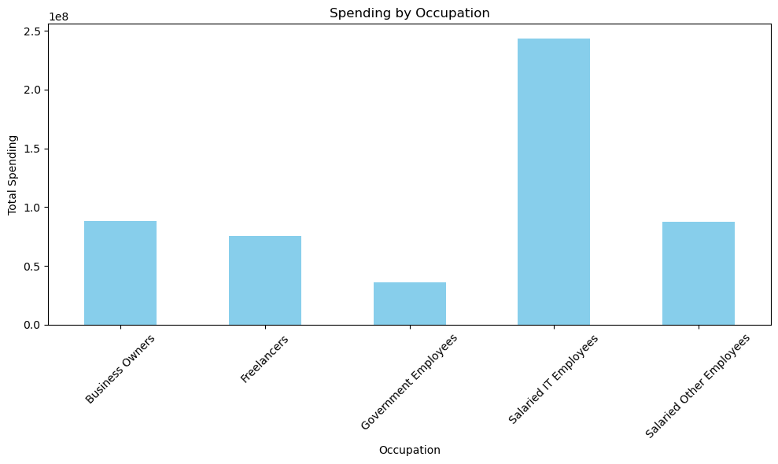

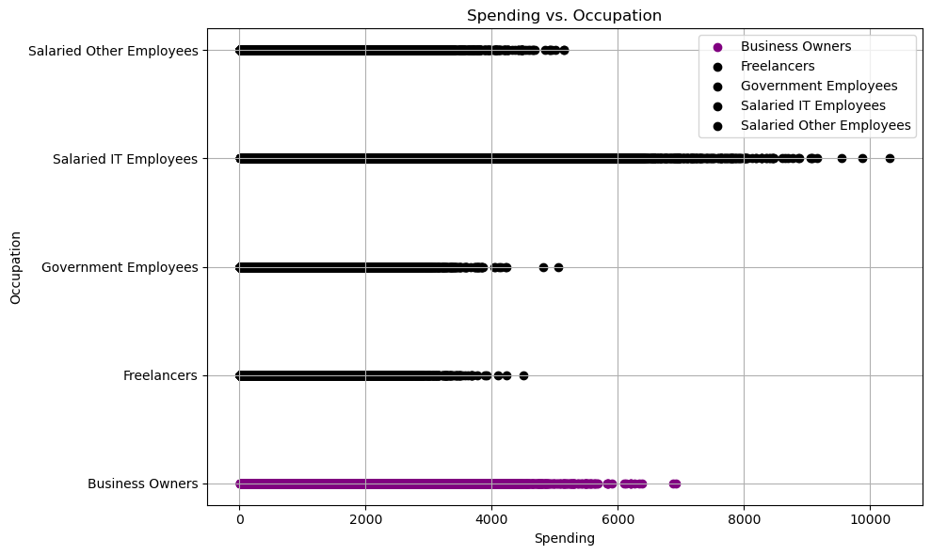

Out of all the provided occupations, it was found that IT Employees spend more than the rest. This was followed by Other Employees.

**Spending Distribution by Occupation**

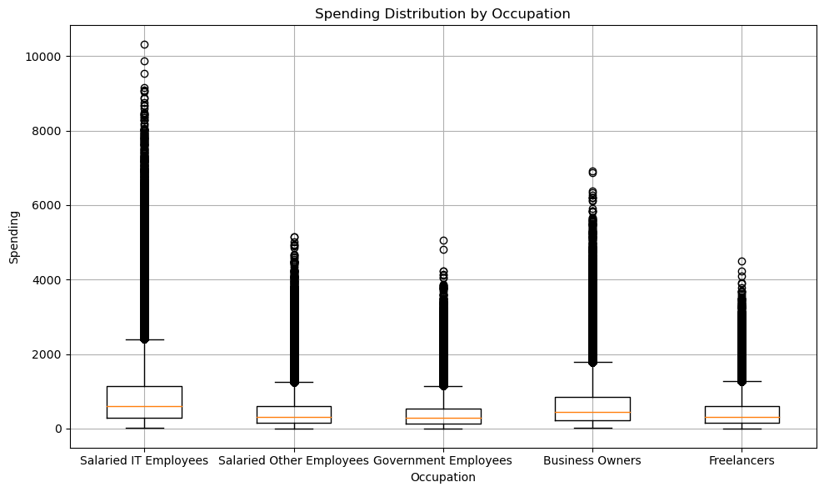

With this spending distribution chart, it can be understood that the average spending of the IT Employees exceeds the rest. This is followed by Business Owners, however every series in this case had multiple positive outliers.

**Spending by Gender**

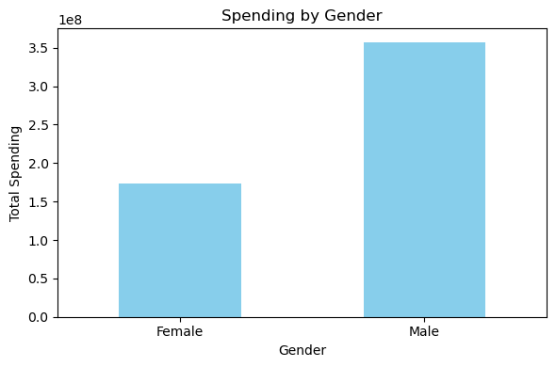

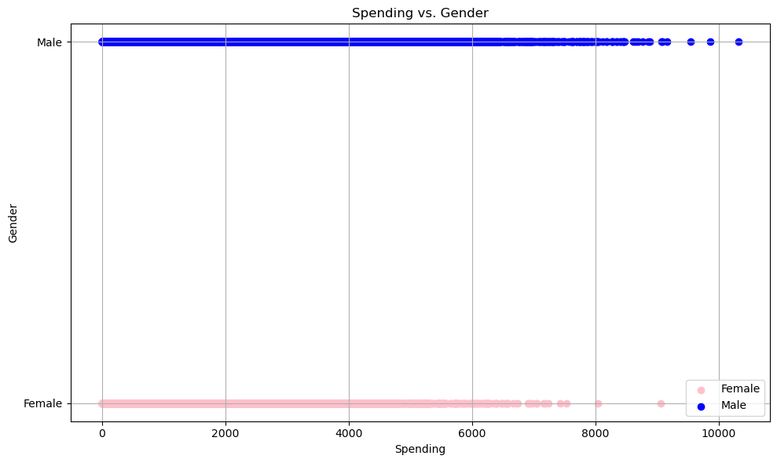

It was found that the Males on average spend more than the Females.

**Spending Distribution by Gender**

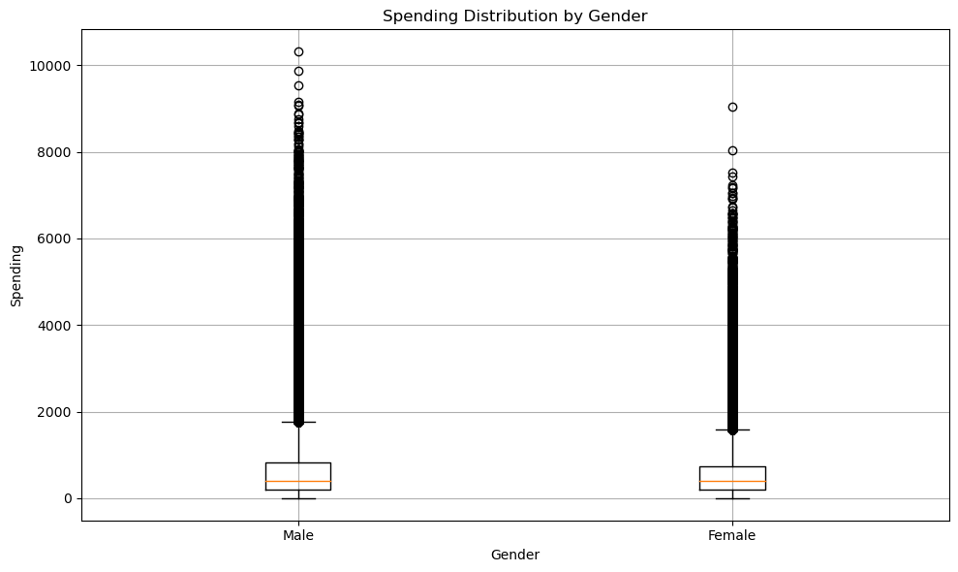

Although Males spend more than Females, they both have similar average spendings and multiple positive outliers.

**Spending vs Average Income**

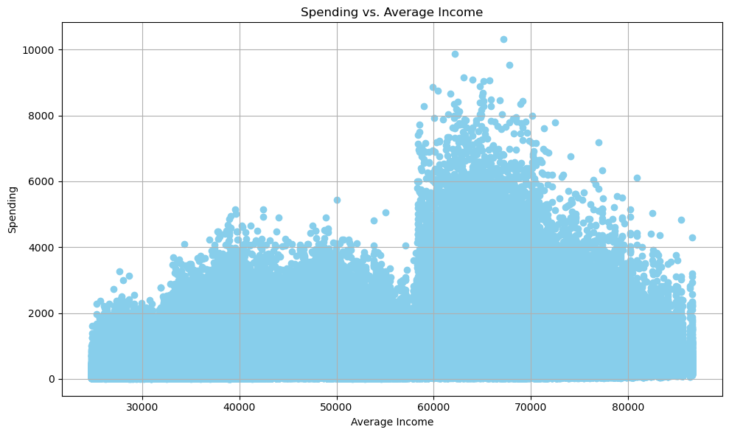

**Conclusion**

Dominant Age Group: Customers aged 25-34 form the largest segment of the customer base and also exhibit the highest spending, indicating a significant focus on this age group for marketing strategies.

Marital Status Influence: Married individuals tend to spend more on average compared to single individuals, yet both groups display similar average spending with notable high-spending outliers.

Occupation Impact: IT Employees are the highest spenders among all occupations, followed by Business Owners, highlighting a key demographic for targeted promotions and offers.

Gender Spending Patterns: While males generally spend more than females, the average spending between the genders is relatively similar, with both having numerous high-spending exceptions.

Income Correlation: The analysis suggests a potential link between spending habits and average income levels, emphasizing the importance of understanding income distribution when assessing customer spending behavior.

**Recommendations**

Target Marketing for Ages 25-34: Develop and implement targeted marketing campaigns and personalized offers for the 25-34 age group, leveraging their significant presence and high spending power.

Marital Status-Based Promotions: Create specialized promotions and loyalty programs for married customers, while also considering engagement strategies to enhance spending among single customers.

Focus on High-Spending Occupations: Design exclusive products or services, as well as marketing initiatives, aimed at IT Employees and Business Owners, who exhibit the highest spending levels.

Gender-Specific Strategies: Craft marketing messages and promotional offers that appeal to both genders, taking into account their similar average spending and recognizing the potential of high-spending outliers in both groups.

Income-Sensitive Offerings: Develop a tiered pricing strategy or a range of products that cater to different income levels, ensuring accessibility and appeal across various income brackets, thereby optimizing spending potential.